# **RichLady_Slot 富婆网赚项目**

**相关SVN地址：**

移除网赚逻辑项目SVN地址：svn://192.168.1.200/live-vegas/branches/RichLady_Slot

网赚项目SVN地址：svn://192.168.1.200/live-vegas/branches/RichLady_Slot_earning

lua调试工具：svn://192.168.1.200/woohoo-se-slots/trunk/common（checkout 到工程的同级目录下）

美术资源SVN地址: svn://192.168.1.200/live-vegas-resource/男性向slots美术资源/富婆网赚0821

策划文档SVN地址：svn://192.168.1.200/woohoo-se-slots/doc/富婆玩法需求文档

外网SVN地址：

#### **运行环境：**

unity：**2021.3.36f1c1**

lua调试：vscode

#### **运行：**

1. 直接打开 或 切换android平台
2. 运行场景 Loadinggame
3. 可能存在的问题：

a c#新增 或者更改lua 调用接口，使用菜单命令 Lua/Generate All 重新生成wrap，

b 如过有报错 使用菜单命令 Lua/Clear wrap files 清除wrap，再操作a

打包机连接：

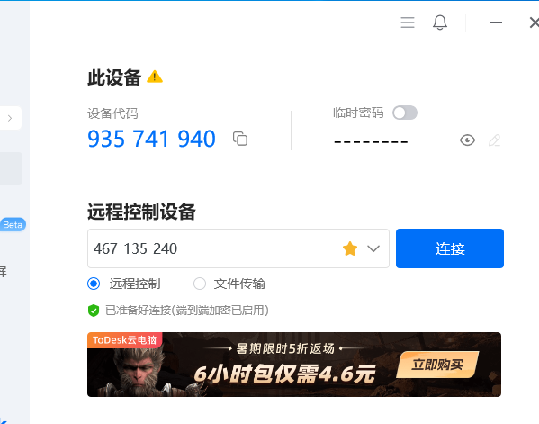

Mac锁屏密码：123456789

远程控制账号：467135240 密码：wt7vi8w1

后台

正式服：game.ios.richladyslots.com

测试服：game.ios.test.richladyslots.com:8080

开发服：<http://192.168.1.202:9060>

网关

正式服：gate.richladyslots.com

测试服：gate.test.richladyslots.com:8080

开发服：<http://192.168.1.202:9061>

测试后台登录：[[测试]Richlady-IOS-运营管理后台 (richladyslots.com)](http://game.ios.test.richladyslots.com:8080/admin/#/index/welcome)

正式后台：<http://game.ios.richladyslots.com/admin/#/index/welcome>

打包地址：http://192.168.195.226:8080/

http://192.168.0.100:8080/

工程：[RichLady_Slot/Assets/Hotfix](http://ld13.a1.luyouxia.net:20620/svn/RichLady_Slot/Assets/Hotfix) 热更资源路径

工程：RichLady_Slot\Assets\Game\Art\Texture UI资源路径

MAC账号及密码：

账号：3341142323@qq.com

密码：37385400aA

Jenkins 登录账号adim 密码：

**Jenkins打包流程配置**：

RichSlot_ZIP（资源包生成、工作空间）

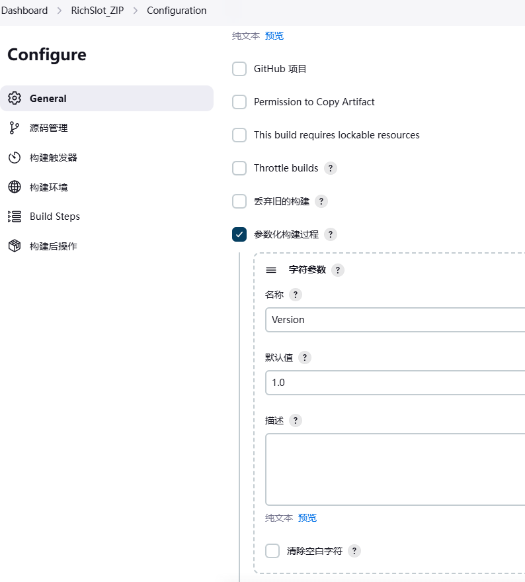

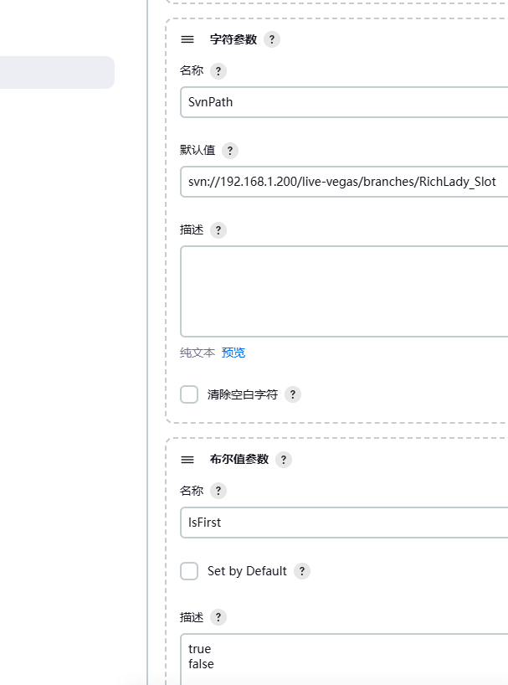

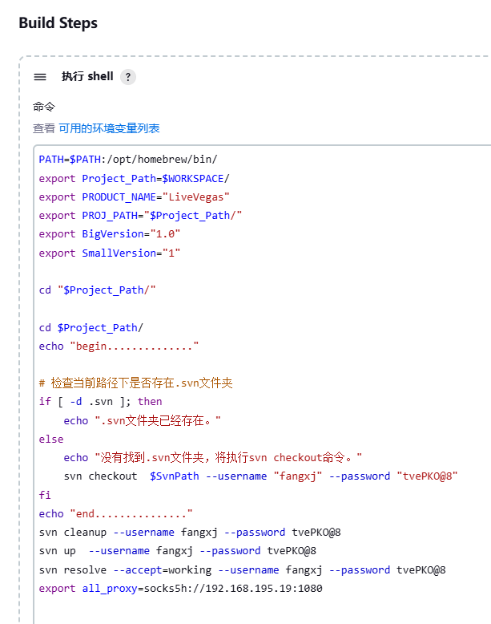

PATH=$PATH:/opt/homebrew/bin/

export Project_Path=$WORKSPACE/

export PRODUCT_NAME="LiveVegas"

export PROJ_PATH="$Project_Path/"

export BigVersion="1.0"

export SmallVersion="1"

cd "$Project_Path/"

cd $Project_Path/

echo "begin.............."

# 检查当前路径下是否存在.svn文件夹

if [ -d .svn ]; then

echo ".svn文件夹已经存在。"

else

echo "没有找到.svn文件夹，将执行svn checkout命令。"

svn checkout $SvnPath --username "fangxj" --password "tvePKO@8"

fi

echo "end..............."

svn cleanup --username fangxj --password tvePKO@8

svn up --username fangxj --password tvePKO@8

svn resolve --accept=working --username fangxj --password tvePKO@8

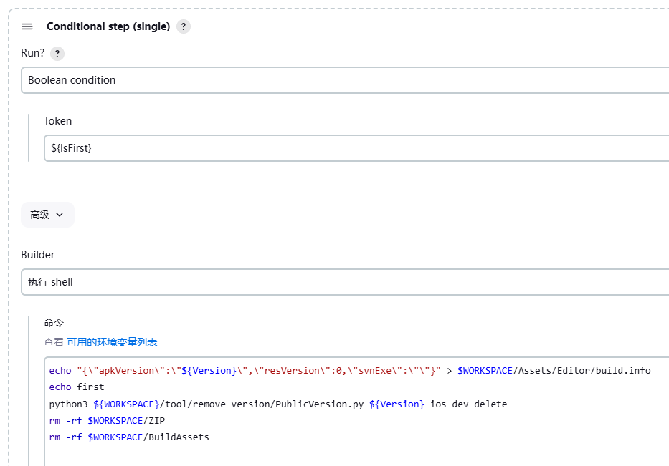

echo "{\"apkVersion\":\"${Version}\",\"resVersion\":0,\"svnExe\":\"\"}" > $WORKSPACE/Assets/Editor/build.info

echo first

python3 ${WORKSPACE}/tool/remove_version/PublicVersion.py ${Version} ios dev delete

rm -rf $WORKSPACE/ZIP

rm -rf $WORKSPACE/BuildAssets

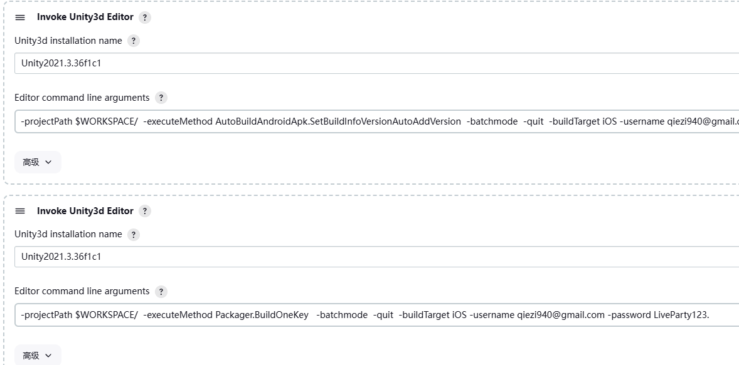

-projectPath $WORKSPACE/ -executeMethod AutoBuildAndroidApk.SetBuildInfoVersionAutoAddVersion -batchmode -quit -buildTarget iOS -username [qiezi940@gmail.com](mailto:qiezi940@gmail.com) -password LiveParty123.

-projectPath $WORKSPACE/ -executeMethod Packager.BuildOneKey -batchmode -quit -buildTarget iOS -username [qiezi940@gmail.com](mailto:qiezi940@gmail.com) -password LiveParty123.

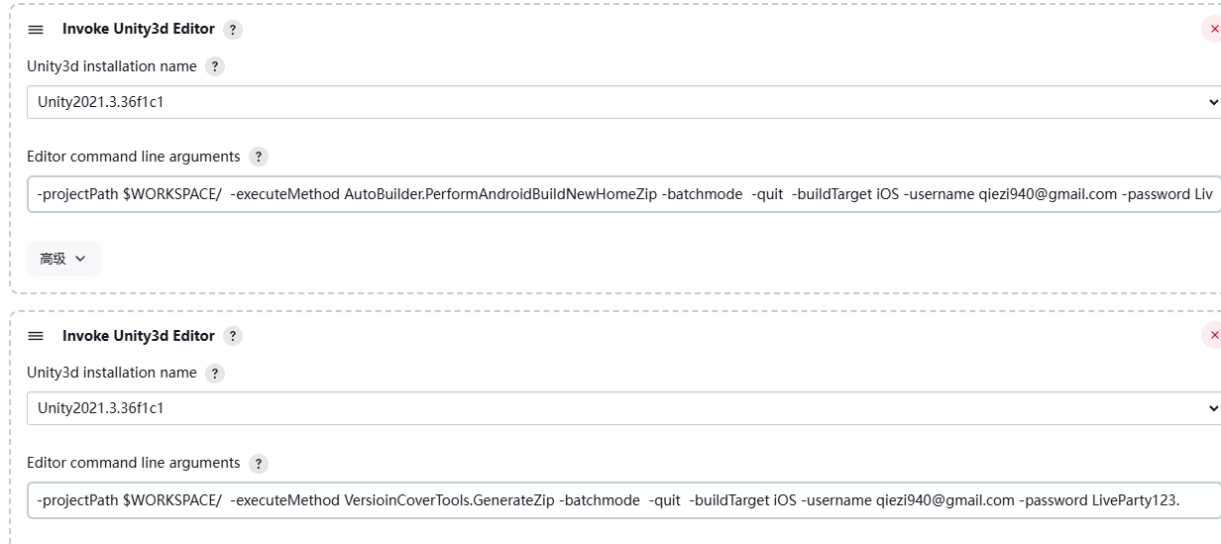

-projectPath $WORKSPACE/ -executeMethod AutoBuilder.PerformAndroidBuildNewHomeZip -batchmode -quit -buildTarget iOS -username [qiezi940@gmail.com](mailto:qiezi940@gmail.com) -password LiveParty123.

-projectPath $WORKSPACE/ -executeMethod VersioinCoverTools.GenerateZip -batchmode -quit -buildTarget iOS -username [qiezi940@gmail.com](mailto:qiezi940@gmail.com) -password LiveParty123.

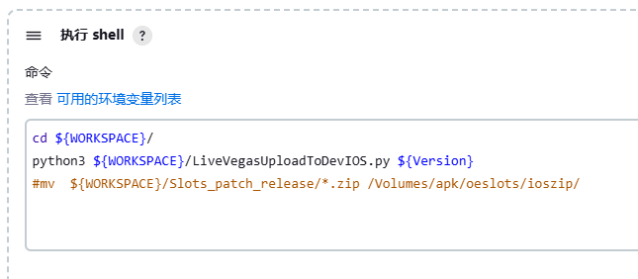

cd ${WORKSPACE}/

python3 ${WORKSPACE}/LiveVegasUploadToDevIOS.py ${Version}

#mv ${WORKSPACE}/Slots_patch_release/*.zip /Volumes/apk/oeslots/ioszip/

RichSlots_IOS(出包)

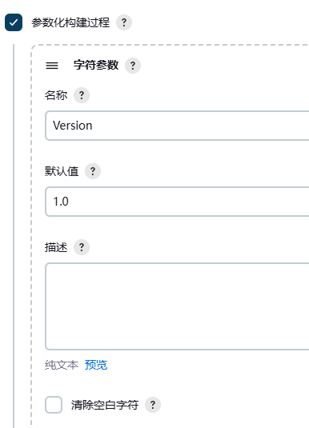

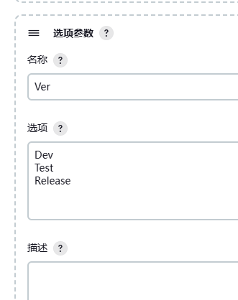

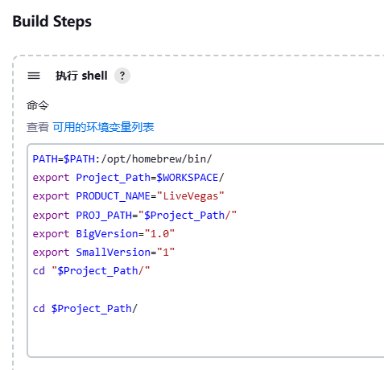

PATH=$PATH:/opt/homebrew/bin/

export Project_Path=$WORKSPACE/

export PRODUCT_NAME="LiveVegas"

export PROJ_PATH="$Project_Path/"

export BigVersion="1.0"

export SmallVersion="1"

cd "$Project_Path/"

cd $Project_Path/

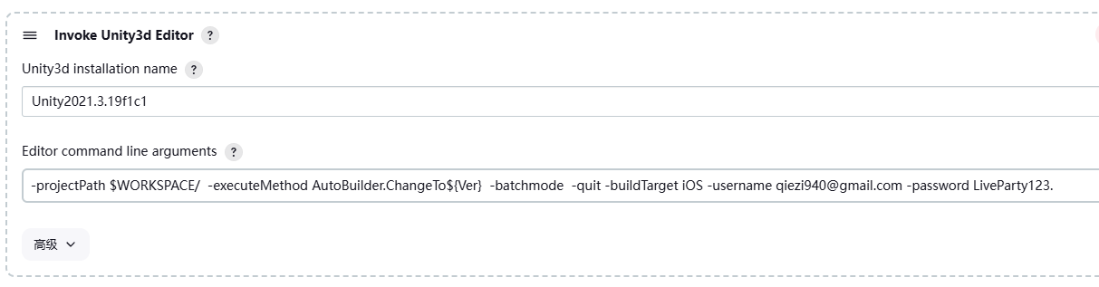

-projectPath $WORKSPACE/ -executeMethod AutoBuilder.ChangeTo${Ver} -batchmode -quit -buildTarget iOS -username [qiezi940@gmail.com](mailto:qiezi940@gmail.com) -password LiveParty123.

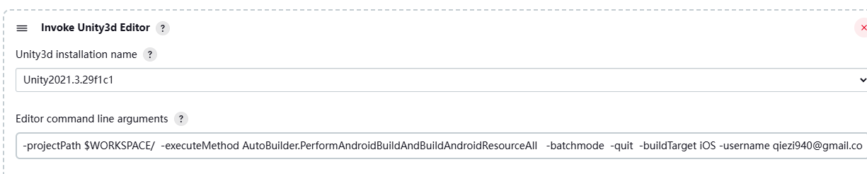

-projectPath $WORKSPACE/ -executeMethod AutoBuilder.PerformAndroidBuildAndBuildAndroidResourceAll -batchmode -quit -buildTarget iOS -username [qiezi940@gmail.com](mailto:qiezi940@gmail.com) -password LiveParty123.

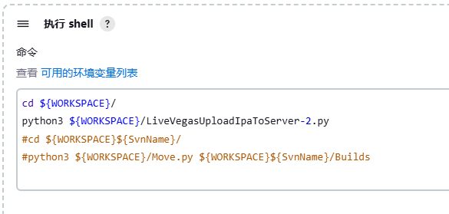

cd ${WORKSPACE}/

python3 ${WORKSPACE}/LiveVegasUploadIpaToServer-2.py

#cd ${WORKSPACE}${SvnName}/

#python3 ${WORKSPACE}/Move.py ${WORKSPACE}${SvnName}/Builds

#### **出包：**